**Lab 5 - Class Diagrams for System Design**

**Introduction**

Class diagrams play a critical role in software engineering, serving as essential tools for understanding, designing, documenting, and visualizing system structures. This lab will guide you through the importance of class diagrams in system design, their components, and how to create them effectively using UML (Unified Modeling Language).

**Objectives**

1. Understand the role of class diagrams in software engineering.
2. Learn to create and interpret class diagrams.
3. Apply UML class diagrams in system design and documentation.

**The Role of Class Diagrams in Software Engineering**

**1. Understanding Requirements**

* **Modeling Requirements**: Class diagrams visualize the system's structure and the relationships between its components, which is crucial for grasping software requirements.
* **Stakeholder Communication**: They serve as a communication tool among stakeholders, ensuring a shared understanding of system functionality.

**2. Design Specification**

* **Translating Requirements into Design**: Class diagrams translate gathered requirements into a detailed design, outlining class interactions, attributes, and methods.
* **Identifying Classes and Relationships**: They help identify necessary classes, properties, methods, and their interrelationships, which are essential for a robust design.

**3. Documentation**

* **Design Documentation**: Class diagrams are integral to system documentation, providing a blueprint that ensures implementation aligns with specified requirements.

**4. System Architecture**

* **High-Level Overview**: Class diagrams illustrate how system components work together, aiding in defining system requirements and constraints.

**5. Iteration and Refinement**

* **Iterative Development**: In Agile methodologies, class diagrams can be revised as requirements evolve, supporting iterative development and refinement of the design.

**Advantages of Class Diagrams in Software Engineering**

**1. Comprehensive Structure**

* **Unified View**: Class diagrams provide a holistic overview of a system's structure, detailing classes, attributes, methods, and relationships to illustrate interactions.
* **Static Structure Representation**: They depict the static aspects of a system, which are essential for defining architecture and design before dynamic behavior is implemented.

**2. Object-Oriented Design**

* **Alignment with Object-Oriented Principles**: Class diagrams align with principles like encapsulation, inheritance, and polymorphism, making them relevant for modern software design.
* **Facilitates Class Creation**: They serve as blueprints that guide developers in creating consistent classes.

**3. Communication and Collaboration**

* **Common Language**: Class diagrams provide a shared language for developers, analysts, and stakeholders, facilitating discussions about functionality and design.
* **Detailed Yet Understandable**: They offer detailed information that is generally easier to grasp for those familiar with object-oriented concepts.

**4. Supports Requirement Traceability**

* **Linking Requirements to Implementation**: Class diagrams trace requirements to corresponding classes and methods, ensuring all functionalities are covered in the design.
* **Change Management**: They can be easily modified to reflect changes in requirements, making them adaptable for iterative development.

**5. Visualization of Relationships**

* **Relationship Mapping**: Class diagrams effectively illustrate associations, aggregations, and inheritances, which are critical for understanding entity interactions.
* **Complexity Management**: They simplify complexity by breaking the system into manageable classes and relationships.

**6. Integration with Other UML Diagrams**

* **Complementary Nature**: Class diagrams can be used alongside other UML diagrams (e.g., sequence and activity diagrams) to provide a comprehensive view of static and dynamic system aspects.
* **Interdependency Representation**: They show interactions among components, which is essential for modeling complex systems.

**7. Ease of Use**

* **Standardization**: As part of UML, class diagrams are standardized and widely recognized in the software engineering community.
* **Tool Support**: Extensive tool support makes creating and maintaining class diagrams easy, facilitating collaboration and updates.

**UML Class Diagram Tutorial**

Class diagrams are among the most valuable types of diagrams in UML, as they effectively represent the structure of a system by modeling its classes, attributes, operations, and relationships between objects. With our UML diagramming software, the process of creating these diagrams becomes more manageable than it may initially seem. This guide will assist you in understanding, planning, and developing your own class diagrams.

**What is a Class Diagram in UML?**

The Unified Modeling Language (UML) provides various methods for modeling systems, with class diagrams being one of the most widely utilized forms. Class diagrams are particularly favored by software engineers for documenting software architecture. They are classified as structure diagrams, as they define the essential components that must be present in the system being modeled.

UML was established as a standardized model to represent an object-oriented programming approach. Since classes serve as the foundational building blocks of objects, class diagrams are considered the fundamental building blocks of UML. The components depicted in a class diagram can represent the classes that will be implemented, the primary objects within the system, or the interactions between classes and objects.

The class shape in a class diagram consists of a rectangle divided into three horizontal sections:

* **Top Section**: Contains the name of the class.
* **Middle Section**: Lists the attributes of the class.
* **Bottom Section**: Outlines the methods or operations that the class may utilize.

Classes and subclasses are organized together to illustrate the static relationships among various objects.

**Member Access Modifiers**

Classes feature different access levels determined by access modifiers (visibility). The following access levels and their corresponding symbols are defined:

* **Public (+)**: Accessible from any other class.
* **Private (-)**: Accessible only within the class itself.
* **Protected (#)**: Accessible within the class and by subclasses.
* **Package (~)**: Accessible only within its own package.
* **Derived (/)**: Indicates derived attributes or methods.
* **Static (underlined)**: Indicates static members that belong to the class itself rather than to instances of the class.

**Member Scopes**

Members within a class diagram can exist in two scopes:

* **Classifiers**: Represent static members that define the structure of the class.
* **Instances**: Refer to specific occurrences of the class, aligning with foundational object-oriented theory.

**Additional Class Diagram Components**

Understanding the basic structure of a class diagram is crucial for comprehending its function in UML. The components include:

* **Classes**: Serve as templates for creating objects and defining behavior within a system. A class represents either an object or a set of objects sharing a common structure and behavior. Classes are depicted as rectangles organized into rows for the class name, attributes, and operations.
* **Name**: The first row within a class shape.
* **Attributes**: The second row, with each attribute displayed on a separate line.
* **Methods**: The third row, shown in list format with each operation on its own line.
* **Signals**: Symbols indicating one-way, asynchronous communications between active objects.
* **Data Types**: Classifiers that define data values, capable of modeling both primitive types and enumerations.
* **Packages**: Shapes that organize related classifiers in a diagram, represented by large tabbed rectangles.
* **Interfaces**: A collection of operation signatures and/or attribute definitions that delineate a cohesive set of behaviors. An interface must be implemented by at least one class.
* **Enumerations**: User-defined data types consisting of groups of identifiers representing the enumeration’s values.
* **Objects**: Instances of classes that can be included in a class diagram to signify either concrete or prototype instances.
* **Artifacts**: Model elements representing tangible entities within a software system, such as documents, databases, executable files, and software components.

**Interactions**

The term "interactions" pertains to the various relationships and connections that can exist in class and object diagrams. Some common types of interactions include:

**1. Inheritance**

Inheritance is the mechanism by which a child or subclass inherits the functionality of a parent or superclass, also known as generalization. This relationship is represented in UML by a straight line with a closed arrowhead pointing towards the superclass.

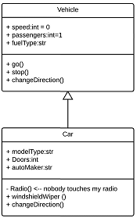

**Example**: The object "Car" inherits attributes (like speed and number of passengers) and methods (like go(), stop(), changeDirection()) from its parent class "Vehicle." In a class diagram, inheritance is depicted by a solid line with a closed, hollow arrowhead.

**2. Bidirectional Association**

Bidirectional association represents the default relationship between two classes, wherein both classes are aware of each other and their relationship. This association is illustrated by a straight line connecting the two classes.

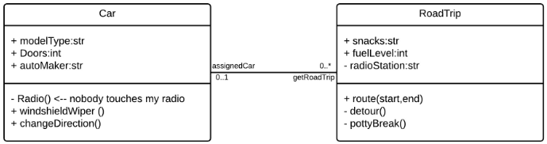

**Example**: The "Car" class and the "RoadTrip" class can be interrelated. The "Car" class may have an association labeled "assignedCar" with a multiplicity value of 0..1, indicating that an instance of "RoadTrip" can either have one instance of "Car" associated with it or none.

**3. Unidirectional Association**

Unidirectional association is a less common relationship where one class is aware of and interacts with the other. This relationship is modeled with a straight connecting line featuring an open arrowhead pointing from the aware class to the known class.

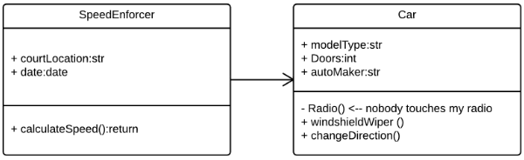

**Example**: In a road trip scenario, a speed camera (not depicted in the diagram) records driving behavior, but the driver only becomes aware of it later via a notification.

**Class Diagram Examples**

Creating a class diagram to map out process flows is straightforward. Below are two examples to guide you as you develop your own class diagrams in UML.

**Class Diagram for a Hotel Management System**

A class diagram can effectively illustrate the relationships between various objects within a hotel management system, encompassing guest information, staff responsibilities, and room occupancy.

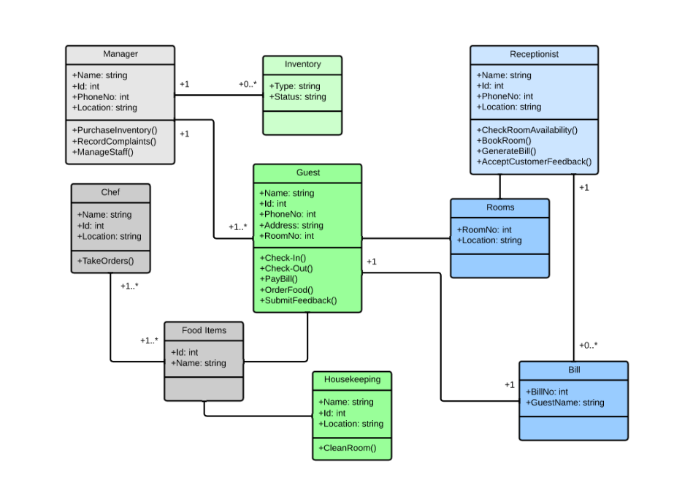

**Class Diagram for an ATM System**

Although ATMs may appear simple—requiring only a few button presses to dispense cash—numerous layers of security must be navigated. The various human and mechanical components of an ATM system are depicted in a clear class diagram.

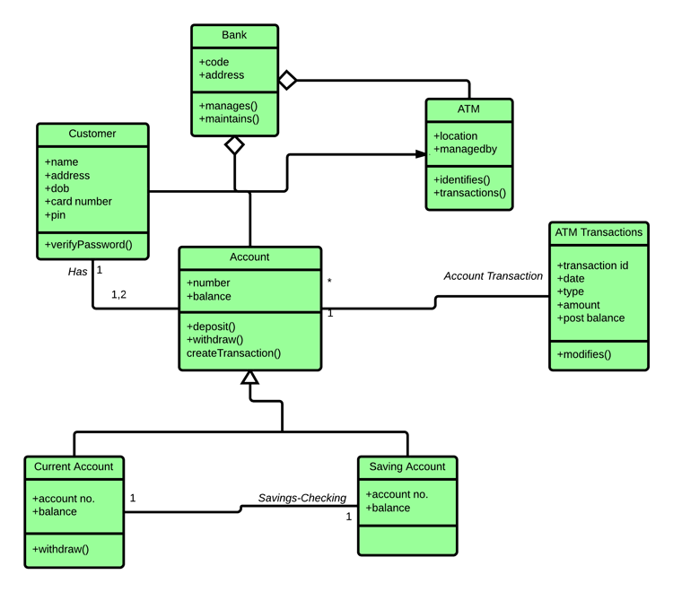

**Class Diagram Creation Tool**

Our UML shape library in Lucidchart enables you to create a wide variety of custom class diagrams using our intuitive UML diagram tool. Additionally, with our "diagram as code" feature, the process of creating a fully customized class diagram has become faster and easier than ever. You can effortlessly generate a unique class diagram and integrate it into your Lucidchart document using Mermaid coding.

## Lab Exercises

1. **Exercise 1**: Create a class diagram for a simple library management system. Include classes for Book, Member, and Loan, detailing their attributes and methods.
2. **Exercise 2**: Using Lucidchart, modify the class diagram you created in Exercise 1 to include relationships between the classes. Document the associations, aggregations, and inheritance present in your design.
3. **Exercise 3**: Research an emerging technology (e.g., AI or cloud computing) and create a class diagram that represents the system architecture involved in that technology.
4. **Exercise 4**: Present your class diagram to the class, explaining how it meets the objectives outlined in this lab manual. Discuss any challenges you faced during the creation process.

**References**

* Unified Modeling Language (UML) documentation
* Lucidchart UML tools and resources
* Agile software development methodologies